**Connecting to Ethereum by using web3**

**Refer the mentioned website for more info**

*https://web3py.readthedocs.io/en/stable/quickstart.html*

**Install pip**

*sudo apt-get install python3-pip*

**install web3 //requirement for web3 python >3.6**

*pip install web3*

**Step1: Start the geth console**

sudo geth --cache 512 --ipcpath "/home/ethereum/testchain.ipc" --identity "testethChain" --rpc -- rpcaddr "localhost" --rpcport "33333" --rpccorsdomain "*" --datadir "/home/ubuntu/ethereum" --port "33333" --nodiscover --rpcapi "admin,miner,personal,db,eth,net,web3" --networkid 333 console –- allow-insecure-unlock

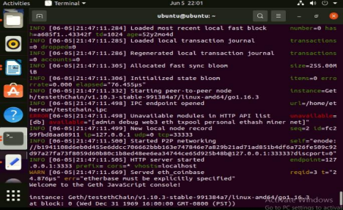

**Step2: Run the test.py to check the connection**

test.py

import web3

from web3 import Web3

w3 = Web3(Web3.HTTPProvider("http://0.0.0.0:33333"))

connected = w3.isConnected()

print(connected)

if connected and w3.clientVersion.startswith('Geth'):

print("connected to geth")

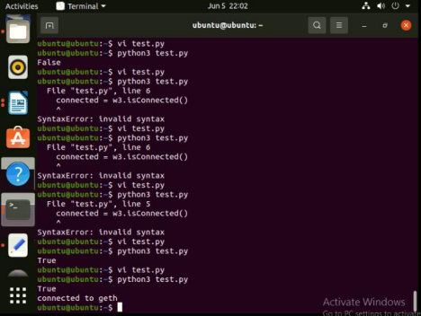

**Step3: Run the test.py to check the latest block**

test.py

import web3

from web3 import Web3

w3 = Web3(Web3.HTTPProvider("http://0.0.0.0:33333"))

connected = w3.isConnected()

print(connected)

if connected and w3.clientVersion.startswith('Geth'):

print("connected to geth")

block = w3.eth.get_block('latest')

print(block)

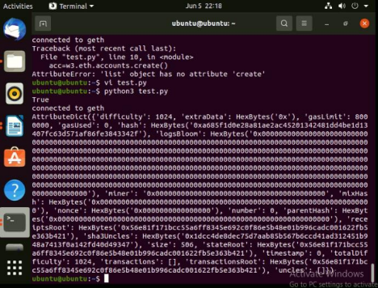

**//Account creation**

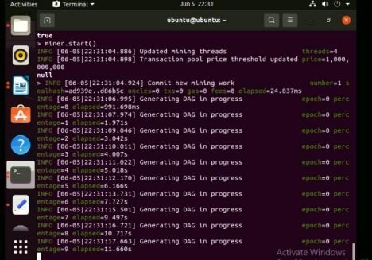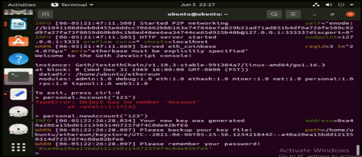

**Step4: Run the test.py to check available accounts**

test.py

import web3

from web3 import Web3

w3 = Web3(Web3.HTTPProvider("http://0.0.0.0:33333"))

connected = w3.isConnected()

print(connected)

if connected and w3.clientVersion.startswith('Geth'):

print("connected to geth")

block = w3.eth.get_block('latest')

print(block)

acc=w3.eth.accounts

print(acc)

